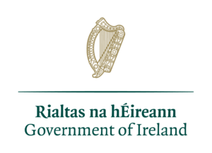

UBU Your Place Your Space

Communications Strategy
Contents
Section 1 – Purpose and Objectives 3
1.1 Statement of Purpose 3
1.2 Background and Current Landscape 3
1.3 Communication Principles 4
Section 2 – Implementation Approach 6
2.1 Identifying Stakeholders 6
2.2 Communication Channels 8
Section 3 – Implementation of Communications Strategy 10

Section 1 – Purpose and Objectives

1.1 Statement of Purpose
UBU Your Place Your Space is a new targeted youth funding scheme which is designed to support and empower young people who experience a greater burden of life’s challenges. The scheme aims to provide services that support young people to develop the personal and social skills required to improve their life chances, including with respect to their health, education, employment and social connectedness.

The scheme has been developed by the Department of Children, Equality, Disability, Integration, and Youth in consultation with the Education and Training Boards (ETB), National Youth Organisations and youth services.

This Communications Strategy will outline how DCEDIY will communicate with all stakeholders in relation to ongoing implementation and development of UBU Your Place Your Space (UBU) scheme. This will include seeking regular feedback from stakeholders in a spirit of commitment to continuous learning and continuous improvement.

It is intended to be a ‘living document’ that informs and guides the communications aspects of the UBU Your Place Your Space scheme on a daily basis. It will be revised and updated as necessary to remain reflective and relevant to any wider changes to the scheme.

This strategy is intended to guide communications with all stakeholders in respect of ongoing implementation of UBU.

1.2 Background and Current Landscape

The overall mission of the UBU Your Place Your Space scheme is to provide out of school supports to young people in their local communities to enable them to overcome adverse circumstances and achieve their full potential by strengthening their personal and social competencies. Young people aged 10 to 24 years of age who are described in the National Youth Strategy (NYS) as marginalised, disadvantaged or vulnerable are the primary target group for services available through the new scheme.

The new scheme was launched on the basis of continuous improvement. This ongoing effort will focus on incremental improvement of aspects of UBU Your Place Your Space during the second cycle of its implementation, 2024 to 2026. Areas for further refinement include quality, outcome measurement, incorporating the voice of the young person, scheme evaluation, and developing a mechanism through which service reviews may be carried out.
The Department is mindful that this scheme represents a large change to the funding mechanism for the youth sector in Ireland and remains cognisant of the fact that further reform of youth sector funding is planned in relation to the Youth Services Grant Scheme, which will affect the broader youth funding environment. Communications surrounding the scheme must manage the reality of the basis of continuous improvement of the scheme within the context of a larger evolving youth funding landscape.

1.3 Communication Principles

In setting the objectives for the Communications Strategy, it is essential that they align with the overall goals for the scheme:
- To provide young person centred, community based, out of school, youth services to young people in need of support
- To ensure that each layer of the governance chain adds value to the direct work with young people
Aligned with the above goals, the primary objective of the Communications Strategy is to communicate the key messages of UBU Your Place Your Space scheme in a manner that:
- is clear, timely, relevant and consistent
- is accessible to all audiences, with consideration given to the marginalised, disadvantaged or vulnerable status of young people engaging in the scheme
- supports effective delivery of the scheme
- meets the identified needs of key stakeholders
- encourages regular feedback with a commitment to continuous learning and continuous improvement
The execution of the Communications Strategy will be undertaken using the following guiding principles
- Communications will be clear and understandable
- Communications will be timely and relevant
- Communications will follow clear and consistent channels
- There will be clear mechanisms for feedback
- Where appropriate, feedback will be responded to

The overarching messages of this Communications Strategy can be summarised as follows:

- UBU is about supporting and empowering young people to reach their full potential
- The scheme will seek to promote outcomes for young people with respect to the seven personal and social development outcomes
- UBU will fund supports for young people between 10 and 24 years old who are experiencing marginalisation or are disadvantaged or vulnerable
- The scheme is underpinned by geographical and thematic needs assessment and robust governance and oversight procedures
- UBU is flexible and adaptable to changing and evolving needs
- UBU aims to make youth services accessible to marginalised, disadvantaged or vulnerable young people through clear and widely available communication
- UBU is grounded in a commitment to continuous improvement - learning through listening

Section 2 – Implementation Approach

2.1 Identifying Stakeholders

The following five classes of external stakeholders have been identified as being particularly relevant for consideration under the Communications Strategy

Each of these stakeholder classes has different needs which are outlined below.
Stakeholder Type | Communication need | Need
Young people who are marginalised, disadvantaged or vulnerable | - Awareness | - Need to know that supports are available, who they are aimed at and how to access them  - Need to have a voice in relation to the ongoing development and continuous improvement of UBU
ETBI  ETBI Youth Support Service | - Formal Engagement/ ETB Comms  - Collaboration and Support to ETBs | - Engagement through formal the structure of ETBI Quarterly meetings. Inclusion on ETB correspondence. Management of ETBI Youth Support Service  - Development of capacity and supports in line with UBU
Education and Training Boards | - Formal communications on governance and funding  - UBU scheme information and collaboration  - Future scheme development  - Capacity building | - Formal written communication and formal engagement through ETBI quarterly forum  - Provision of detailed information and collaboration on how the scheme will operate in practical terms, how to manage governance and oversight of scheme  - Support continuous improvement  - Define capacity needs
Funded Organisations – Boards of Management and Staff | - Formal communications on governance, management and funding  - UBU scheme information and collaboration  - Future scheme development  - Capacity building | - Formal written communication channelled through ETBs  - Provision of detailed information and collaboration channelled through ETBs, how to report information and engage in scheme  - Support continuous improvement  - Define capacity needs
Public  - elected representatives  - press/media | Awareness and accountability | - Must receive briefings as appropriate, answers to PQs and regular update on progress on the development and implementation of the UBU scheme.  - Local and national, online and print.

Different stakeholder groups will have different information needs at different times, requiring different engagement mechanisms. Respecting and reflecting this, a tiered system of communication and engagement will be applied to differentiate the level of detail supplied, timing of information released, level of consultation and influence over policy issues etc.

2.2 Communication Channels

Clear and effective communication with the above stakeholders is dependent upon the correct channelling of information within the UBU Your Place Your Space governance structures. Operationally the governance structure is set up as follows.
- The Minister and the Department of Children, Equality, Disability, Integration, and Youth are the lead agency and grantor of the UBU Your Place Your Space scheme, responsible for setting the UBU budget and policy, allocating funding and overseeing implementation and evaluation. All funding for UBU is provided by the Minister for Children, Equality, Disability, Integration, and Youth having been voted on by the Oireachtas.
- The Education and Training Boards administer the funding to local providers and act as the governance and oversight body. The ETB role involves conducting a local needs analysis for approval by the Department, implementing the Performance and Oversight Engagement Framework (POEF) and supporting funded organisations in delivering services to young people.
- Funded Organisations deliver supports and services directly to young people in line with their individual needs and the scheme’s policy objectives. They will report directly to the ETB primarily through the POEF process.

The Communications Strategy, respecting and reflecting this governance structure, and taking into account the specific nature of communication required, will operate a cascade system of communication for the dissemination of information. Communication feedback will also in general pay due attention to the governance chain and formal structures in place for communicating with the Department. The Department also has stakeholders within the wider interdepartmental and government sector in which it has responsibilities. These include the Minister, the Government, An Taoiseach and other government departments. The Department will also on occasion engage other stakeholders, for example National Youth Organisations, however the primary communication chain will operate in line with the scheme’s governance chain.

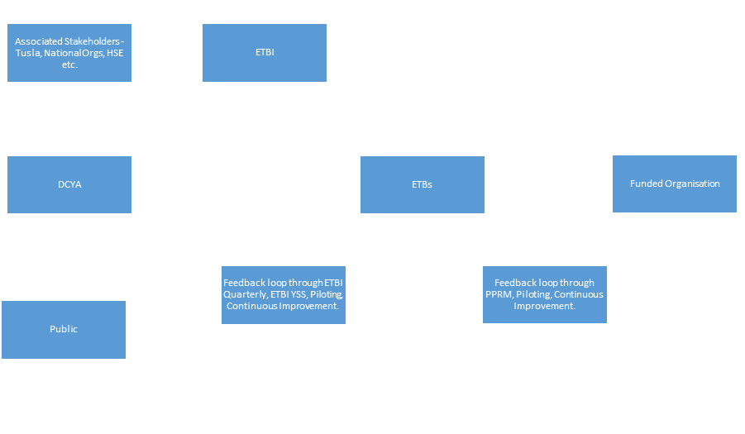
Under this hierarchy each stakeholder has specific responsibilities that must be adhered to in order to ensure the clear and consistent delivery of information which, in turn, supports the effective delivery of services and supports to young people.
Stakeholder | Communication Responsibility
DCEDIY | Responsible for:  - generating communications, materials etc. for UBU scheme  - Channelling communications through ETBs  - Ensuring that UBU Your Place Your Space communications are issued in line with UBU Policy and Operating Rules branding requirements  - Providing clear and consistent information on a dedicated UBU website, as appropriate  - Communicating directly with ETBs in relation to oversight and procedural matters of UBU  - Communicating directly with associated stakeholders for public dissemination of information
ETB | Responsible for:  - Communicating with the Department through appropriate channels using existing structures  - Disseminating Department issued communications to Funded Organisations without edit in a timely manner  - Ensuring that UBU Your Place Your Space branding is in line with UBU Policy and Operating Rules branding requirements  - Providing feedback to ensure one position through existing structures  - Communicating directly with Funded Organisations in relation to operational and funding procedures of the UBU  - Receiving and processing UBU feedback and communications from Funded Organisations, responding appropriately
ETBI | Responsible for:  - Ensuring that, where possible, ETBs communicate a single position to the Department on a given topic  - Utilising existing ETB networks and forums to discuss topics and formulate communications  - Engaging ETBI Youth Support Service to collate feedback from all 16 ETBs
Associated Stakeholders | Responsible for:  - Collaborating in relation to the continuous improvement of UBU where appropriate, however continuous improvement will predominantly be facilitated through the ETBs  - Receiving and disseminating UBU communication as appropriate, however normal dissemination of UBU material will be through ETBs  - Utilising website to retrieve UBU information and resources
Funded Organisation | Responsible for:  - Communicating directly with ETBs through appropriate channels  - Ensuring that UBU communications are disseminated to the Board and staff without edit in a timely manner  - Communicating with young people in the community who may be eligible for participation in the UBU scheme  - Ensuring that relevant issues are reported back to the ETB
Public | Responsible for utilising website to retrieve UBU information

Section 3 – Implementation of Communications Strategy

The Communications Strategy is publicly available on the UBU website https://ubu.gov.ie/. Documents to support the running of the scheme are also available in advance of the scheme becoming operational.
The UBU Communications Strategy, similar to the UBU scheme itself, was launched in line with the concept of continuous improvement.
The ongoing development of the UBU scheme, through the UBU Implementation Plan, will be communicated to stakeholders as appropriate through the channels set out in the previous sections. The Department will continually seek to improve, through the maintenance and update of the Communication Strategy, communication approaches and mechanisms. The current document is the initial outline of the Department’s strategy, however it will be continuously reviewed and updated in consultation with various stakeholders, particularly the ETBs.

